Grid Synchronization on Three Phase Synchronous Generators

Syed Usman shah

*Department of Electrical Electronics Engineering*

*Ghulam Ishaq Khan Institute of Engineering Sciences and Technology*

*Topi, Khyber Pakhtunkhwa, Pakistan*

# Usmanshah1998.us@gmail.com

***Abstract* - This following document elaborates about the modern era Synchronous Generators. The respective text intends to cover subjects such as synchronization and techniques of synchronization. It further discusses about the pros and cons of these techniques. More over the content tries to brief about today’s grid connected generators and the ways active and reactive power load sharing contribute to system.**

***Index Terms – Synchronization, Synchronous generators, grid connected generators, three phase synchronizations.***

# I. INTRODUCTION

We all are well aware of alternators and AC generators that are used to generate AC power. Synchronous generators are one of the alternators types that also uses the electromagnetic induction properties to translate mechanical current into AC electrical current at a specific speed and frequency. The alternators “synchronous generators” produces the AC power at synchronous speed and of required frequency referring the name.

The synchronous generators always follow a constant speed when converting mechanical power into electrical power. These generators work on the basis of Faraday laws of electromagnetic induction. According to the concept of electromagnetic induction an electromotive force is generated when the armature coils rotates in the constant magnetic field thus forming sinusoidal curve.

The design of synchronous generator consists of two major component that is stator and rotor. The rotor is the rotating tool that is vital field rod whereas stator as name suggest is the stationary tool of the machine that consist of armature loop to generate voltage.

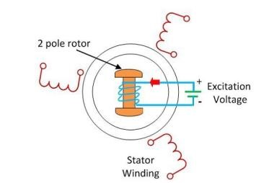

## FIGURE I

*A. Synchronization*

In general synchronization is define as a process of conducting of multiple operations giving a simultaneous response at the same time and rate (ScienceDirect, 2022). Whereas, when talking about generators synchronization it is defined as the process of toning different variables that are voltage, frequency, phase angle, phase sequence and waveform of the machine.

The concept of synchronization is used in the generators when two or more alternators are required to produce power to the field. The synchronization is applied before coupling the generators to manage the intensive load as the electrical field varies.

The generators are synchronized with each other or power system and the generators are synchronized before they are recoupled with power system or each other. Once they are synchronized the system can run uniformly.

II. CONSIDERATIONS FOR SYNCHRONIZATION

To synchronize a machine to the power system some important parameters must be considered for the uniform production of the power. These considerations involve:

1. Phase sequence
2. Voltage amplitude
3. Frequency
4. Phase angle

*1)Phase sequence:*

Phase sequence or phase rotation is defined as the sequence in which a waveform is delivered to its end. When synchronizing a machine with the system the phase sequence of the alternator must follow the same phase sequence as of the system.

*2)Voltage amplitude:*

Voltage magnitude is defined as the maximum value reached through the supply voltage. In the synchronization process the voltage magnitude of the machine should equalize the voltage magnitude of the system.

1. *Frequency:*

Frequency referred to the number of recurring events per unit of time. The frequency of the wavelength produced by the generator must follow the frequency of the wavelength produced by power system.

1. *phase angle:*

Phase angle is defined as the phase shift between the total voltage and total electric load. The phase angle between the voltage attained by alternator and the voltage attained by the system should be zero.

# III. TECHNIQUES OF SYNCHRONIZATION

*A) Synchroscope*

When two or more machines are being synchronized, the phase angle differences between them are measured using a device called a synchroscope. Splitting the load on the power system's bus bar requires synchronization. The following are synchronization's fundamental prerequisites:

1. The incoming voltage's amplitude equalizes.
2. The machines are in synchronization with one another.
3. The machines continue to run at the same frequency.

The three-phase machines must be in phase with one another in order for them to operate simultaneously. At the time of installation, the device's phase sequence is accurate.

In relation to the three-phase system, the Synchroscope analyzes the input voltage of the machines. The synchroscope is seen in the following figure. It has a dial that is situated on the motor's circular scale of calibration. The dial's position reveals the phase difference among the endless machines and the incoming voltage.

## FIGURE II

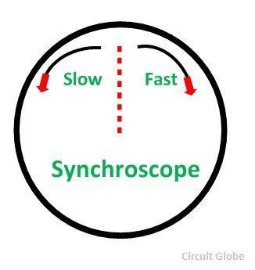

Two arrows denote the scale of the Synchroscope to show the way of pointer rotation. The pointer's clockwise and counter clockwise directions are indicated by the arrow. The incoming machine rotates slowly in the anti-clockwise direction while moving too quickly in the clockwise direction. The machine's movement in relation to the bus bar is indicated by the arrow. The pointer will deviate in the direction of the fast mark if the incoming machine's frequency is higher than the generators. Additionally, the pointer will deflect towards the direction of the slow mark if the incoming machine's frequency is lower.

TABLE I

## SYNCHROSCOPE METHOD PROS AND CONS

|  |  |
| --- | --- |
| Pros | Cons |
| Comparatively accurate than Lamps Method | Costly |
| The operator's subjective estimation of the precise  synchronization time is almost completely eliminated. | It cannot display a phasesequence because it is a single-phase instrument. |

*B) Synchronization by Indicating Lamps*

To examine the prerequisites for paralleling or synchronizing the receiving machine with the other machine, a set of three synchronizing lamps might be employed. The method below uses a dark bulb and a voltmeter to synchronize. Low-power machinery is mostly utilizing this technique.

### FIGURE III

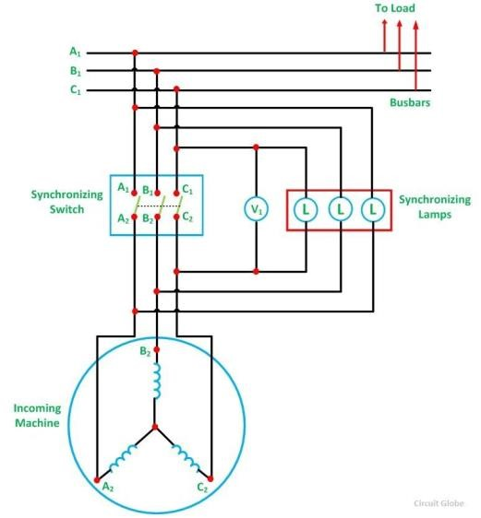

The incoming machine's prime mover is turned on and accelerated toward its rated speed. The arriving machine's field current is modified in order for it to match the bus voltage. The three lamps blink at a rate equal to the difference between the frequencies of the bus and the incoming machine. If the phases are properly connected, all of the bulbs will turn on and off simultaneously. If this criterion is not met, the phase sequence is improperly connected.

Therefore, two leads to the line of the incoming machine should be switched in order to connect the machine in the proper phase sequence. The incoming machine's frequency is changed till the lamp flickers slowly. Less than one dark phase should occur each second is the ideal flicker rate. In the middle of their dark phase, the synchronization switch is closed after finally regulating the incoming voltage.

TABLE II

DARK LAMP METHOD PROS AND CONS

|  |  |
| --- | --- |
| PROS | CONS |
| This approach costs less. | This approach costs less. The lamp's filament could burn out. |
| Finding the proper phase order is simple. | Finding the proper phase order is simple.  At roughly half of its rated voltage, the bulb dims.  As a result, even when there is a phase discrepancy between the machines, the synchronization switch may be turned off. |
| - | Which lamp has the higher frequency is not indicated by which lamp flickers more frequently. |

## *C) two dark one light bulb method*

This approach can be used to determine whether the alternator frequency is lower or greater than the bus bar frequency. The connections are indicated in the image below.

### FIGURE IV

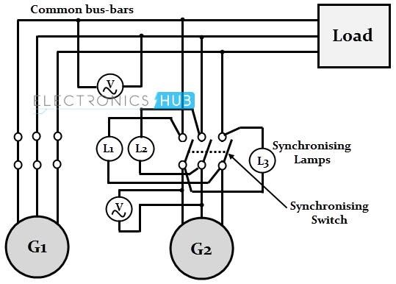

While the lights L1 and L3 are connected in a transposed fashion in this instance, lamp L2 is connected across the pole in the center line of the synchronizing switch in a manner similar to the dark lamp approach.

Similar to the earlier procedure, the voltage condition testing is followed by a series of bright and dim bulb glows. The order in which the lamps turn on and off determines whether the alternator frequency is lower or greater than the bus bar frequency.

The primary mover increases the alternator's speed until the flickering is reduced to the absolute minimum. At the precise moment that lamps L1 and L3 are similarly bright and lamp L2 is dark, the synchronizing switch is then shut off.

This method's drawback is that the proper phase sequence cannot be verified. For permanently connected alternators, it is sufficient to check the phase sequence for the first time of operation alone, negating the need for this criterion.

*D) Automatic Synchronization*

The circuit breaker does not need to be manually closed during automatic synchronisation. The automatic synchronizer handles every step of the process; that is, it keeps track of the frequency, voltage, and phase angles, adjusts the signal to match the frequency and voltage, and finally provides an output contact to terminate the circuit.

An automatic generator should always be allocated to every generator because it's crucial to restore electricity following a power outage. This facilitates a very speedy parallel connection between each generator and the main bus.

The generator voltage is then supplied to the synchronizer while the mover accelerates the generator to the proper speed. The synchronizer begins to detect the current bus and incoming phase angel, voltage and frequency when the minimum voltage reaches a minimum value.

TABLE III

### AUTOMATIC SYNCHRONIZATION METHOD PROS AND CONS

|  |  |
| --- | --- |
| Pros | Cons |
| More reliable | Costly |
| Precise alternator operation, measurement, and monitoring. | Hard to maintain |
| Does not call for extra operators, greatly reducing the possibility of human error. | - |

The two-step and three-step approaches are straightforward and simple to grasp, as illustrated in the table, although they involve manual labour and could take some time(Tim-bus, Liserre, Teodorescu, & Blaabjerg, 2005). There also runs the danger of human error, which might jeopardize the power system's dependability and stability. The variables of the generator can be precisely controlled with the synchronized automatic synchronization method and the parallel operation method, which are both quick and effective. They do, however, call for a complicated control system that can be more expensive to put into place.

*E) Relay for Sync Check*

The slip frequency, voltage variance, and phase-angle deviations between the bus and approaching generator are compared using the sync check relay. Until all the conditions are met, the relay will not permit closing the circuit breaker. Because the supervisory relay connections are closed after the operator manually closes the operator control switch, the

circuit breaker only shuts off when the switch is closed

# IV. GRID CONNECTED GENERATORS

*Active Power and reactive power Sharing (kW)*

Active power, commonly referred to as real power, is the energy used in a power system to carry out practical tasks like operating motors and for the lighting of structures. Reactive power, commonly referred to as imaginary power, is the energy required by AC systems to regulate the electrical field but does not perform any meaningful tasks.

The operator controls the active power output of a synchronous generator that is connected to the grid, while the excitation system of the generator automatically controls the reactive power output. To keep the voltages at the terminals of generator constant, the excitation system modifies the field current of the generator.

To meet the system's power requirements and maintain the ideal balance between active and reactive power, a generator's active and reactive power outputs can be modified and proper balance is then maintained between reactive and active powers. This phenomenon is known as power sharing. There are various ways to accomplish the task of power sharing, including the use of electronic power devices like static vary compensators (SVCs) or by modifying the excitation system of the generator. Power sharing can occasionally also be accomplished by coordinating with other generators or load-shedding techniques.

In order to preserve the stability and dependability of a power system, the right balance between active and reactive power must be maintained. Voltage instability and problems with power quality might result from a high reactive power demand. If the demand for reactive power is too low, on the other hand, transmission lines may become overloaded and the stability of the system may be compromised.

The field excitation in a synchronous generator is the current fed into the field winding, which produces a magnetic field surrounding the stator. The prime mover, like a gas turbine or steam turbine, determines the speed of the generator. The generator's output voltage is affected by the magnetic field's strength, the stator winding's number of turns, and the generator's speed. The generator's speed and the quantity of poles in its stator winding determine its frequency.

*Field excitation:*

by raising the field excitation, the magnetic field strengthens and raise the generator's output voltage. The losses in the generator will also grow as the field excitation is increased, which could lower the generator's efficiency.

*Speed:*

The generator's frequency will rise as its speed does as well. Beyond a certain point, however, raising the speed will also result in a drop in the generator's output voltage because the magnetic material inside the generator's core will become saturated.

*Output voltage:*

The generator's output voltage is inversely proportional to the magnetic field's intensity and is directly proportional to the excitation of field. Additionally, it also relates proportionally to the generator's speed and the stator winding's number of turns.

*Frequency:*

Generator speed and the quantity of poles in the stator winding have a direct correlation with the frequency of the generator. It is significant to recognize the interdependence of these relationships and the potential effects of changing one variable on the others. When the field excitation is increased, for instance, the generator's output voltage may rise, but the efficiency of the generator ends up suffering. Similar to this, raising the generator's speed may raise its frequency while it simultaneously lowers the output voltage of generator due to the saturation of the magnetic material in the core of the generator.

## V.Conclusion

According to my opinion, synchronizing of synchronous generators to a power system is generally best accomplished using the automated synchronization technique. With this technique, the generator' voltage, speed and frequency are automatically adjusted to match the specifications of the power system. In order to keep the generator's terminal voltage constant, the control system can also change the excitation level.

The automatic synchronization method's ability to be quick and effective because it doesn't require user involvement is one of its major characteristics. When the system needs to be swiftly powered back on in an emergency, this can be quite helpful. Furthermore, the automatic synchronization technique can lessen the possibility of human error, which can contribute to enhancing the dependability and stability of the power system.

The capacity to precisely manage the generator's parameters, which can help to increase the system's stability and power quality, is another benefit of the automatic synchronization technique. The control system's ability to automatically change the generator's output to suit systems' charging power demand also makes it possible for the generator to be easily integrated into the power grid.

As a result of its quick and effective operation, increased dependability and stability, and capacity to offer exact control of the generator's parameters, the automatic synchronization method is my preferred approach for synchronizing synchronous generators to a power system.

REFERENCES

1. Thompson, M. J. (2012). Fundamentals and advancements in generator synchronizing systems. *2012 65th Annual Conference for Protective*

*Relay Engineers*.

https://doi.org/10.1109/cpre.2012.6201234

1. Han, Y., Li, H., Shen, P., Coelho, E. A. A., & Guerrero, J. M. J. I. T. o. P. E. (2016). Review of active and reactive power sharing strategies in hierarchical controlled microgrids. *32*(3), 2427-2451.
2. Rosini, A., Labella, A., Bonfiglio, A., Procopio, R., Guerrero, J. M. J. R., & Reviews, S. E. (2021). A review of reactive power sharing control techniques for islanded microgrids. *141*, 110745.
3. Schaefer, R. C., & Kim, K. J. I. I. a. m. (2001). Excitation control of the synchronous generator. *7*(2), 37-43.
4. Schaefer, R. C. J. I. T. o. I. A. (2016). Art of generator synchronizing. *53*(1), 751-757.
5. Timbus, A., Liserre, M., Teodorescu, R., & Blaabjerg, F. (2005). *Synchronization methods for three phase distributed power generation systems-An overview and evaluation.* Paper presented at the 2005 IEEE 36th Power Electronics Specialists Conference.
6. Workbook, A. E. (2021, June 27). *Dark Lamp*

*Method of Synchronization of Generator (or Alternator)*. ElectricalWorkbook. https://electricalworkbook.com/dark-lamp-method/

1. *[Solved] Which of the following is NOT an advantage of relays?* (n.d.). Testbook. Retrieved

December 18, 2022, from

https://testbook.com/question-answer/which-of-thefollowing-is-not-an-advantage-of-rela--

615bfef1b9b6a264569e0873

1. Govindasamy, R. (2020, May 4). *ACTIVE & REACTIVE POWER SHARING IN PARALLELED GENERATORS*

*(KW & KVAR)*. DieselShip.

https://dieselship.com/marine-technical-articles/marineelectro-technology/active-reactive-power-sharing-in-aparalleled-generator-set-kw-kvar/#:~:text=systems

1. Jarzyna, W. (2019). A survey of the synchronization process of synchronous generators and power electronic converters. *BULLETIN of the POLISH ACADEMY of SCIENCES TECHNICAL SCIENCES*, *67*(6).

https://doi.org/10.24425/bpasts.2019.131565